Background subtraction in OpenCV

Background subtraction is a way of eliminating the background from image. To achieve this we extract the moving foreground from the static background.

In OpenCV we have three algorithms to do this operation:

1. **BackgroundSubtractorMOG**

It is a Gaussian Mixture-based Background/Foreground Segmentation Algorithm.

### 2. BackgroundSubtractorMOG2

It is also a Gaussian Mixture-based Background/Foreground Segmentation Algorithm. It provides better adaptibility to varying scenes due illumination changes etc.

### 3. BackgroundSubtractorGMG

### This algorithm combines statistical background image estimation and per-pixel Bayesian segmentation.

How to apply OpenCV in-built functions for background substraction:

1. Create an object to signify the algorithm we are using for background subtraction.
2. Apply backgroundsubtractor.apply() function on image.

Python code:

#importing libraries

import numpy as np

import cv2

#creating object

fgbg1 = cv2.bgsegm.createBackgroundSubtractorMOG();

fgbg2 = cv2.createBackgroundSubtractorMOG2();

fgbg3 = cv2.bgsegm.createBackgroundSubtractorGMG();

# capture frames from a camera

cap = cv2.VideoCapture(0);

while(1):

#read frames

ret, img = cap.read();

#apply mask for background subtraction

fgmask1 = fgbg1.apply(img);

fgmask2 = fgbg2.apply(img);

fgmask3 = fgbg3.apply(img);

cv2.imshow('Original',img);

cv2.imshow('MOG',fgmask1);

cv2.imshow('MOG2',fgmask2);

cv2.imshow('GMG',fgmask3);

k = cv2.waitKey(30) & 0xff;

if k == 27:

break;

cap.release();

cv2.destroyAllWindows();

Output:

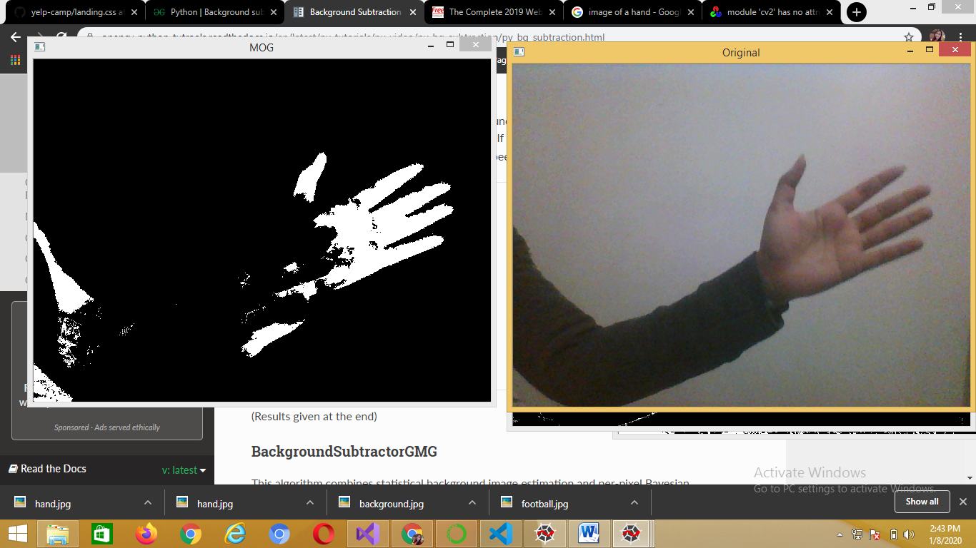

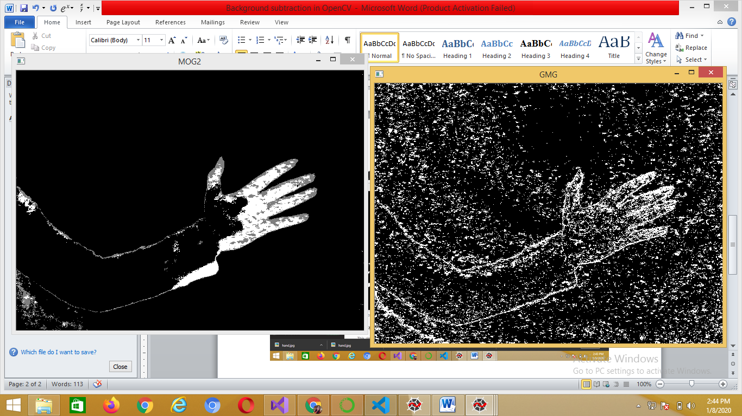

We can see that there is a lot of noise in the resultant image for BackgroundSubtractorGMG, hence it is always preferred to use morphological transformation to the result to remove the noises.

Python code:

#importing libraries

import numpy as np

import cv2

kernel = cv2.getStructuringElement(cv2.MORPH_ELLIPSE,(3,3));

#creating object

fgbg = cv2.bgsegm.createBackgroundSubtractorGMG();

# capture frames from a camera

cap = cv2.VideoCapture(0);

while(1):

#read frames

ret, img = cap.read();

#apply mask for background subtraction

fgmask = fgbg.apply(img);

#with noise frame

cv2.imshow('GMG noise',fgmask);

#apply transformation to remove noise

fgmask = cv2.morphologyEx(fgmask, cv2.MORPH_OPEN, kernel);

#after removing noise

cv2.imshow('GMG',fgmask);

k = cv2.waitKey(30) & 0xff;

if k == 27:

break;

cap.release();

cv2.destroyAllWindows();

Output:

